# 1.

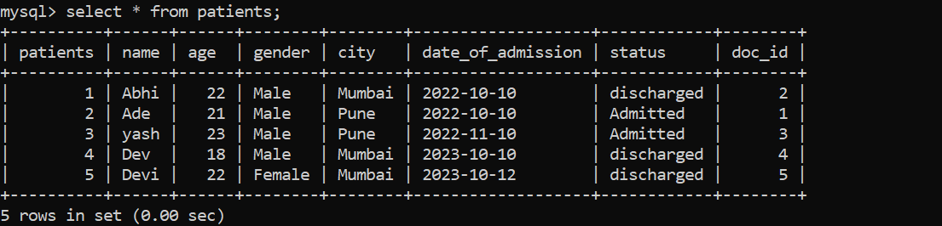

mysql> select * from patients;

+----------+------+------+--------+--------+-------------------+------------+--------+

| patients | name | age | gender | city | date_of_admission | status | doc_id |

+----------+------+------+--------+--------+-------------------+------------+--------+

| 1 | Abhi | 22 | Male | Mumbai | 2022-10-10 | discharged | 2 |

| 2 | Ade | 21 | Male | Pune | 2022-10-10 | Admitted | 1 |

| 3 | yash | 23 | Male | Pune | 2022-11-10 | Admitted | 3 |

| 4 | Dev | 18 | Male | Mumbai | 2023-10-10 | discharged | 4 |

| 5 | Devi | 22 | Female | Mumbai | 2023-10-12 | discharged | 5 |

+----------+------+------+--------+--------+-------------------+------------+--------+

5 rows in set (0.00 sec)

# 2.

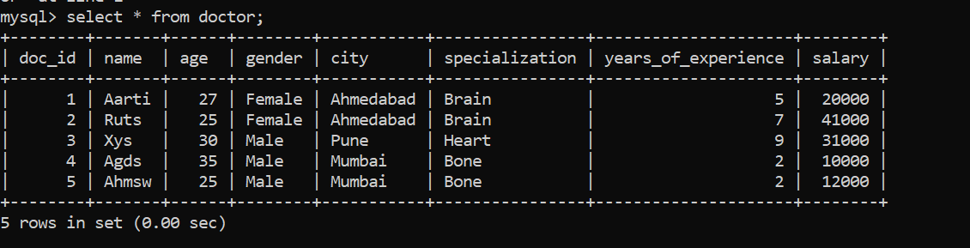

mysql> select * from doctor;

+--------+-------+------+--------+-----------+----------------+---------------------+--------+

| doc_id | name | age | gender | city | specialization | years_of_experience | salary |

+--------+-------+------+--------+-----------+----------------+---------------------+--------+

| 1 | Aarti | 27 | Female | Ahmedabad | Brain | 5 | 20000 |

| 2 | Ruts | 25 | Female | Ahmedabad | Brain | 7 | 41000 |

| 3 | Xys | 30 | Male | Pune | Heart | 9 | 31000 |

| 4 | Agds | 35 | Male | Mumbai | Bone | 2 | 10000 |

| 5 | Ahmsw | 25 | Male | Mumbai | Bone | 2 | 12000 |

+--------+-------+------+--------+-----------+----------------+---------------------+--------+

5 rows in set (0.00 sec)

# 3.

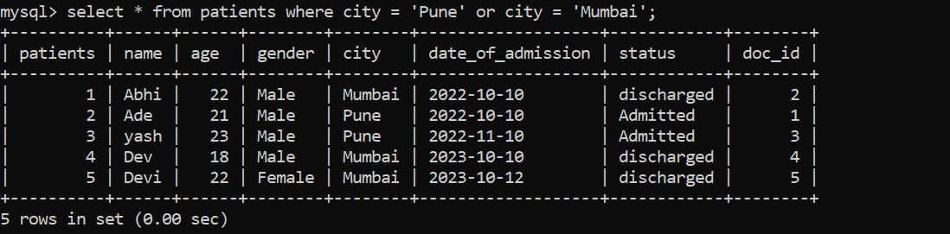

# 4.

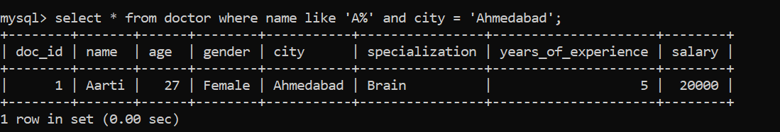

# 5.

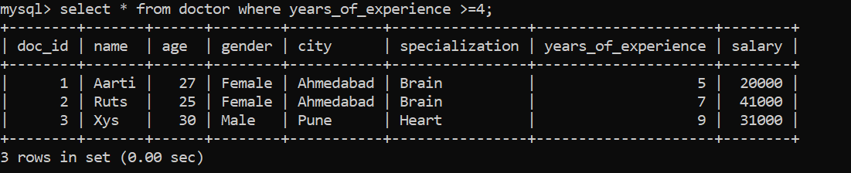

# 6.

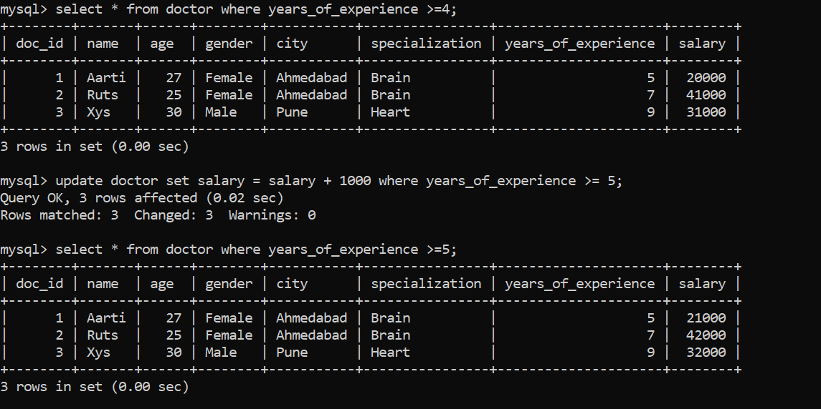

# 7.

